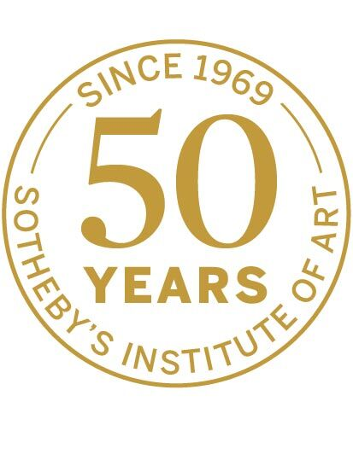

Refugee Art Dealers in Britain
Dates: 02 November, 2019
Time: 14:30 – 19:15
Tickets at £15/£10

A half-day conference co-organized by Sotheby’s Institute of Art and TIAMSA, The International Art Market Studies Association.

The aim of this event is to explore the experiences, impact and significance of those art dealers who fled Nazi Europe and set up in the UK before or during the Second World War. In line with other aspects of culture and enquiry at this time, this experience of dislocation changed the art world significantly as well as the status of particular artists and artistic movements, opening up channels for the dissemination of the new trends of the 1920s and 1930s. Celebrating the 50th anniversary of the foundation of Sotheby’s Institute of Art, this event will combine short papers by experts in the field and a panel discussion which will contextualize the experiences and achievements of those who lived through these dramatic times.

Speakers include Richard Aronowitz, Cherith Summers, Fran Lloyd, Sue Grayson Ford, Jutta Vinzent, Sarah MacDougall and Lucy Wasensteiner.

This event is part of the Insiders/Outsiders Festival insidersoutsidersfestival.org

Saturday, 2nd November

14:30-15:00 Arrival and Registration
15:00-15:10 Welcome and Introduction
Dr Jonathan Woolfson, Sotheby’s Institute of Art
15:10-15:40 Refugee Dealers and the London Art Market, Summer 1938
Dr Lucy Wasensteiner, Bonn University
15:40-16:10 Radical Female Role-models: Pioneering Gallerists Erica Brausen and Mutter Ey
Cherith Summers, Murphy & Partners / Co-curator, Brave New Visions – The Émigrés who Transformed the British Art World
16:10-16:30 Gains and Pitfalls of Émigrés as Art Dealers. The Modern Art Gallery and the London Gallery
Dr Jutta Vinzent, University of Birmingham
16:30-16:45 Panel Discussion

16:45-17:15 Tea/Coffee

17:15-18:30 Round Table
Moderator: Dr Johannes Nathan, The International Art Market Studies Association
Richard Aronowitz, European Head of Restitution, Sotheby’s London
Sue Grayson Ford, Founder of The Serpentine Gallery and The Big Draw; Co-curator, Brave New Visions: The Émigrés who Transformed the British Art World
Professor Fran Lloyd, Kingston University
Sarah Mac Dougall, Ben Uri Gallery and Museum

18:30-19:15 Wine Reception

